Hi,

Assume I have 4 Value Lists, each containing 3 items:
ValueList_A (contains A1, A2, A3)
ValueList_B (contains B1, B2, B3)
ValueList_C (contains C1, C2, C3)
ValueList_D (contains D1, D2, D3)

I create a ‘master’ view that has a default grouping level of:
ValueListA->ValuetList_B->ValueList_C

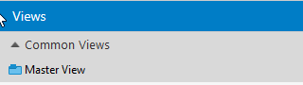

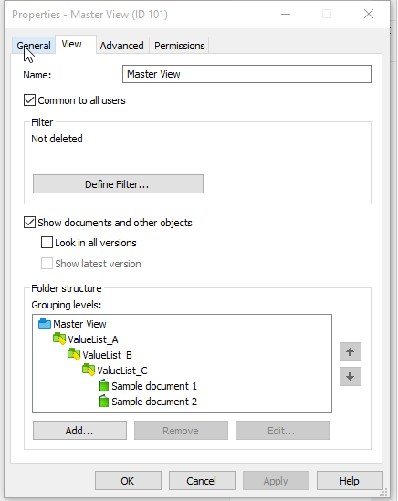

Now, here’s the problem:

I’m trying to create a nested view within the master view that has different grouping level FOR A SPECIFIC ITEM IN VALUE LIST B.
For example, INSERT the ValueList_D as a grouping level for the B2 item of ValueList_B.
So something like this:

A1 -> B1 -> C1
C2
C3
A1 -> B2 -> D1 -> C1
C2
C3
D2 -> C1
C2
C3
D3 -> C1
C2
C3
A1 -> B3 -> C1
C2
C3

To do this, I expand the Master View to A1:
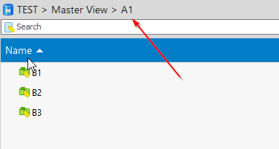

And I customize the B2 virtual folder to make it a nested view:
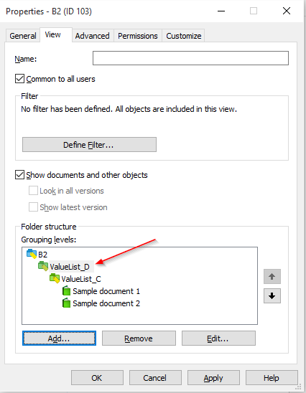

The B2 item is now a view:

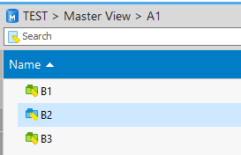

The problem is this new view *only* applies to A1->B2, and not A2->B2 and A3->B2:

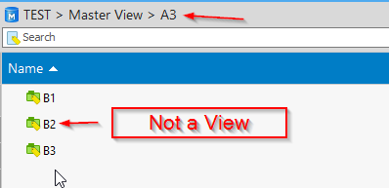

So the question is, is it possible to create a view in M-Files that behaves like this:

A1->B1->C1,2,3
A1->B2->D1->C1,2,3
A1->B2->D2->C1,2,3
A1->B2->D3->C1,2,3
A1->B3->C1,2,3

A2->B1->C1,2.3
A2->B2->D1->C1,2,3
A2->B2->D2->C1,2,3
A2->B2->D3->C1,2,3
A2->B3->C1,2,3

A3->B1->C1,2.3
A3->B2->D1->C1,2,3
A3->B2->D2->C1,2,3
A3->B2->D3->C1,2,3
A3->B3->C1,2,3

Thanks.

If it helps I could include the test vault backup file.

